
Roof Condition Assessment
Pre-Hurricane Season Bi-Annual Condition Assessment
Windemere at Ponte Vedra Beach Condominium Association
Buildings One and Two
900 Spinnakers Reach Drive, Ponte Vedra, FL 32082
Report Number: RCA-20260514-001
Inspection Date: May 14, 2026
Inspection Type: Pre-Hurricane Season Bi-Annual Condition Assessment
Report Issued: May 15, 2026
Prepared by:
Charles Taylor
Kristophor C. Linster, P.E., RRC, CBECxP, LEED AP BD+C, CDT, RRO, CEI
Principal Engineer
kcl@cts-engco.com
Prepared for:
Windemere at Ponte Vedra Beach Condominium Association
c/o Marsh Landing Management Company

Section 2: Executive Summary
Charles Taylor performed an in-person bi-annual roof condition assessment of Windemere at Ponte Vedra Beach Condominium Association on May 14, 2026. The inspection covered Buildings One and Two at 900 Spinnakers Reach Drive, Ponte Vedra, FL 32082. The inspection occurred within the pre-hurricane-season window recommended for Northeast Florida coastal properties and serves as the dated photographic baseline of record for the 2026 storm season.
Property Roof Systems
The property contains two distinct roof systems with different ages and conditions, which are reported separately throughout this document:
- Modified Bitumen Roof, Areas B1-MB and B2-MB (central low-slope areas on Buildings 1 and 2). Installed in 2025 replacing the original Built-Up Roofing (BUR) system. Charles Taylor served as Engineer of Record for design and construction administration. One year in service. Condition rating: GOOD. Performing as designed.
- Concrete Tile Mansard, Areas B1-TM and B2-TM (sloped flanking areas on Buildings 1 and 2). Existing roof system pre-dating the 2025 reroof scope. Estimated 10 to 12 years of remaining service life. Condition rating: FAIR. Active maintenance items present plus capital planning awareness for end-of-life replacement.
- Chimney Chases, Area B1-CH (Building 1 only; Building 2 has no chimneys). New aluminum louvered caps installed under the 2025 scope per drawing A701. Internal chimney spark arrestors above the flues are unit-owner-controlled and were not part of the 2025 common-element scope (see Section 9).
Findings Count by Severity
S1: Critical | S2: Major | S3: Moderate | S4: Monitor
0 | 3 | 5 | 1
Modified Bitumen Roof (2025): Maintenance Items
The 2025 modified bitumen system is performing as designed in its first post-installation bi-annual review. Three maintenance items warrant attention before the June 1, 2026 hurricane season start:
- F-1: Ponding water at internal drains and along screen wall base, dissipates within 48 hours. Severity S4, confidence C-High.
- F-2: Surface rust transfer from condenser support stands onto adjacent membrane and screen-wall panels. Severity S3, confidence C-High.
- F-3: Granule and debris accumulation at drains, scuppers, and inside corners; one scupper with bird-nest debris. Severity S3, confidence C-High.
Concrete Tile Mansard (Existing): Active Items and Capital Awareness
The existing concrete tile mansard shows active condition items consistent with a tile system in the latter third of its 10 to 12 year remaining service life:
- F-4: Broken concrete tile at sidewall flashing on oceanfront-facing slope. Severity S2, confidence C-High.
- F-5: Cracked tile with rust bleed at sidewall step flashing. Severity S2, confidence C-High.
- F-6: Cracked hip tile with non-compliant field mastic repair. Severity S2, confidence C-High.
- F-7: Cracked tile and exposed proud fastener on tile slope. Severity S3, confidence C-High.
- F-8: Non-compliant field mastic repair at tile hip joint. Severity S3, confidence C-High.
- F-9: Mismatched replacement tiles in valley indicating end-of-supply-line condition. Severity S3, confidence C-High.
Owner-Controlled Item: Chimney Spark Arrestors
Severe corrosion of the ferrous chimney spark arrestors above the chimney flues was documented within the new aluminum chimney caps installed under the 2025 reroof scope. These spark arrestors are unit-owner-controlled components and are not common-element property of the Association; they could not be replaced as part of the 2025 common-element reroof. The Association should formally notify the affected unit owners. See Section 9 for the detailed sidebar.
Estimated Remaining Service Life
Modified bitumen roof (2025): 24 to 28 years of remaining service life. Concrete tile mansard (existing): 10 to 12 years of remaining service life. Begin capital planning for tile mansard replacement within the next 5 to 7 years.

Section 3: Property and Roof System Description
Windemere at Ponte Vedra Beach Condominium Association is a multi-building oceanfront luxury condominium community within the Marsh Landing community in Ponte Vedra Beach, St. Johns County, Florida. The property's east-facing roof edges sit at the immediate Atlantic Ocean shoreline within ASCE 7-22 Exposure D and within 500 feet of the shoreline (ISO 9223 Class C5 corrosion environment).
Engineer of Record History
Charles Taylor served as Engineer of Record for the design and construction administration of the 2025 modified bitumen roof replacement covering Areas B1-MB and B2-MB on Buildings One and Two. The original Built-Up Roofing (BUR) system was removed and replaced with a multi-ply modified bitumen assembly over specified insulation on the existing concrete roof deck. The existing concrete tile mansard (B1-TM and B2-TM) was not part of that scope and pre-dates the 2025 reroof. The Building 1 chimney chases (B1-CH) received new aluminum caps under the 2025 scope per drawing A701, but the internal spark arrestors above the flues remain unit-owner-controlled. This continuity of engineering knowledge informs the condition ratings and service-life forecasts in this report.
Roof Areas
B1-MB, Building 1, Modified Bitumen Roof. Central low-slope membrane roof on Building 1. Installed 2025 replacing original BUR per drawings dated May 9, 2024. Multi-ply modified bitumen over specified insulation on existing concrete deck. Charles Taylor served as Engineer of Record.
B1-TM, Building 1, Concrete Tile Mansard. Existing concrete flat tile mansard slopes flanking the central low-slope area on Building 1. Pre-dates the 2025 reroof scope. Estimated 10 to 12 years of remaining service life.
B1-CH, Building 1, Chimney Chases. Stucco-clad chimney chases with new aluminum chimney caps installed under the 2025 scope per drawing A701. Internal chimney spark arrestors above the flues are unit-owner-controlled (not common element).
B2-MB, Building 2, Modified Bitumen Roof. Central low-slope membrane roof on Building 2. Installed 2025 replacing original BUR per drawings dated May 9, 2024. Multi-ply modified bitumen over specified insulation on existing concrete deck. Charles Taylor served as Engineer of Record.
B2-TM, Building 2, Concrete Tile Mansard. Existing concrete flat tile mansard slopes flanking the central low-slope area on Building 2. Pre-dates the 2025 reroof scope. Estimated 10 to 12 years of remaining service life.
Construction Drawings of Record
The Windemere Condominiums Roof Replacement (Buildings One and Two) construction drawings were issued May 9, 2024. The drawing set comprises four sheets that define the 2025 mod-bit reroof assembly as built and serve as the as-designed reference for this assessment:
- C001: Cover Sheet
- A101: Roof Plans
- A501: Roof Details
- A701: Chimney Details
Full drawing images are reproduced in Appendix F. References to specific drawings appear throughout this report (for example, A501 detail 9 for the metal coping cap and A701 for the new aluminum chimney cap).
Rooftop Equipment Inventory
The modified bitumen roof carries multiple HVAC condenser units supported on ferrous angle-iron stands resting on liquid-flashed pads. The condenser units and their support stands are HVAC-service-vendor equipment that predate the 2025 roof scope; the 2025 scope reset the membrane and target-ply detailing beneath each existing stand but did not replace the stands themselves. Other rooftop equipment documented includes turbine vents, mushroom-cap fan vents, PVC plumbing vent stacks, and the chimney chase enclosures.

Section 4: Site and Code Context
Jurisdiction. St. Johns County, Florida (Building Division).
Florida Building Code. FBC 8th Edition (2023), including FBC-EB Section 706 reroof triggers.
HVHZ Status. NOT in the High-Velocity Hurricane Zone. HVHZ applies only to Miami-Dade and Broward Counties.
Wind Loading. ASCE 7-22 governing. Risk Category II (residential condominium). Vult approximately 140 mph. Exposure Category D (immediate oceanfront). Roof zones 1 (field), 2 (edge), and 3 (corner) each carry distinct uplift pressure requirements.
Wind-Borne Debris Region. Yes. St. Johns County is within the wind-borne debris region.
Secondary Water Resistance. Required per FBC 2023 Section 1503. Confirmed present on the 2025 modified bitumen installation.
Florida Statute 553.899 (SB 4-D). Mandatory milestone inspection of condominium buildings 3+ stories within 3 miles of the coastline. Initial inspection due at 25 years, then every 10 years. SIRS required every 10 years.
OIR-B1-1802 (Rev. 04/26). Florida Office of Insurance Regulation uniform wind mitigation form, effective April 1, 2026.
Corrosion Class. ISO 9223 Class C5 within 500 ft of shoreline.

Section 5: Inspection Methodology
Kristophor C. Linster, P.E., conducted an in-person bi-annual roof condition inspection on May 14, 2026. The inspection covered the modified bitumen roof fields (Areas B1-MB and B2-MB), the perimeter screen-wall assemblies, the internal drains and through-wall scuppers, the rooftop equipment, the Building 1 chimney chase enclosures (Area B1-CH), and visible portions of the concrete tile mansard slopes (Areas B1-TM and B2-TM). Sixty-seven (67) photographs were captured during the inspection and form the documentary record of this report.
Scope and Method
This was a visual condition assessment performed from accessible roof surfaces and from vantage points on the modified bitumen roof field. No destructive testing, no infrared moisture survey, and no uplift testing were performed as part of this bi-annual cycle. Findings are based on direct visual observation supported by the photographic record. The engineer of record continuity for the 2025 modified bitumen system informs the interpretation of the membrane field condition.
Severity and Action Window Rubric
Tier | Definition | Action Window
S1: Critical / Emergency | Active leak, structural risk, or immediate failure potential. | 0-30 days
S2: Major | Significant condition; will worsen rapidly without action. | 30-90 days
S3: Moderate | Active condition; address before next bi-annual cycle. | 90 days-1 year
S4: Monitor | Within normal envelope; monitor at next inspection. | Next inspection

Section 6: Findings Register
This section documents 9 findings identified during the inspection, grouped by roof system. Each finding includes location, component, condition, cause, severity, confidence, recommended action, action window, applicable standard, and supporting photograph identifiers.
Modified Bitumen Roof (Installed 2025)
ID | Area | Component | Condition and Recommended Action | Sev/Conf | Photos
F-1 | B1-MB / B2-MB | Drainage, Internal Drains and Screen Wall Base | Ponding water at internal drains and along screen wall base, dissipates within 48 hours. Ring-pattern wet staining was observed around several internal roof drain bowls and along low points at the metal screen wall base. Field inspection confirmed that standing water dissipates within 48 hours of a rain event, which is within the NRCA threshold for low-slope membrane systems. The pattern is consistent with the designed slope geometry directing water toward drains and overflow scuppers and does not represent a system deficiency.  Action: Monitor at each bi-annual inspection. Re-confirm dissipation timing after the first significant rain event of each season. No corrective work required at this time. Window: Monitor at next bi-annual (post-hurricane season, November-December 2026). Standard: NRCA 48-hour ponding threshold for low-slope membrane. | S4 / C-High | P-010, P-017, P-041, P-050, P-057
F-2 | B1-MB / B2-MB | HVAC Equipment, Condenser Support Stands | Surface rust transfer from condenser support stands onto adjacent membrane and screen-wall panels. Multiple HVAC condenser units are supported on ferrous angle-iron stands that are showing coastal surface corrosion. Rust runoff is depositing on the white reflective membrane surface, on the liquid flashing pads beneath each stand, and on adjacent metal screen wall panels. The membrane itself is not penetrated or compromised; the staining is cosmetic at this stage, but the upstream support stands are the active source and warrant attention before further deposition accumulates.  Action: Coordinate with the HOA and the HVAC service vendor on a plan to either (a) replace the ferrous support stands with 316 stainless steel or hot-dip-galvanized assemblies during the next condenser servicing cycle, or (b) institute a freshwater rinse cadence on the stands and adjacent membrane per coastal best practice. Concurrently, soft-wash existing rust transfer from the membrane and screen-wall panels using low-pressure water and a pH-neutral cleaner. Document cleaning for warranty record. Window: 60-180 days for membrane and panel cleaning. Stand replacement coordinated with HVAC service schedule. Standard: Coastal best practice; ISO 9223 Class C5; ASTM A123 (if hot-dip galvanizing path selected). | S3 / C-High | P-003, P-004, P-008, P-009, P-012, P-013, P-041, P-055, P-059, P-060, P-062, P-066
F-3 | B1-MB / B2-MB | Drainage, Drains and Scuppers | Granule and debris accumulation at drains, scuppers, and inside corners; one scupper with bird-nest debris. Granule accumulation and minor organic debris are present at the strainer domes of several internal drains, in the throats of through-wall scuppers, and in the inside corners along the metal screen wall base. One through-wall scupper on an oceanfront-facing parapet is partially obstructed by a bird nest. Loose ferrous fasteners are present on the membrane field in one location and should be removed to prevent membrane puncture.  Action: Clear all drains, scupper throats, and inside corners of accumulated granules and debris. Remove the bird nest from the obstructed scupper. Install code-compliant scupper basket strainers sized to retain debris without restricting flow. Remove loose ferrous fasteners from the membrane field. Add monthly drain-and-scupper inspection to the facilities maintenance log. Complete before the start of the 2026 Atlantic hurricane season on June 1. Window: 0-30 days. Complete before June 1, 2026. Standard: FBC 2023 Section 1503.4 drainage. | S3 / C-High | P-014, P-034, P-035, P-042, P-043
Concrete Tile Mansard (Existing)
ID | Area | Component | Condition and Recommended Action | Sev/Conf | Photos
F-4 | B1-TM / B2-TM | Tile, Field at Sidewall Flashing | Broken concrete tile at sidewall flashing on oceanfront-facing slope. Two adjacent concrete flat tiles are fractured at the sidewall flashing interface on an oceanfront-facing slope of the existing tile mansard. The SBS underlayment and a fastener are exposed at the fracture location. Located in ASCE 7-22 Zone 3 Exposure D, the most wind-uplift-sensitive zone on the property.  Action: Replace damaged tiles in kind (matching available stock per F-9 below). Verify underlayment integrity beneath; if compromised, replace local section of underlayment and re-install tiles per FRSA/TRI Florida High Wind Concrete and Clay Tile Installation Manual. Use only 316 stainless or hot-dip-galvanized fasteners. Window: 30-60 days. Complete before June 1, 2026 hurricane season start. Standard: FRSA/TRI Florida High Wind Concrete and Clay Tile Installation Manual; FBC 2023 Section 1518. | S2 / C-High | P-030, P-033
F-5 | B1-TM / B2-TM | Tile, Field at Step Flashing | Cracked tile with rust bleed at sidewall step flashing. Cracked concrete tile at sidewall step flashing on an oceanfront-facing tile mansard slope, with rust bleed at the counterflashing reglet and calcium efflorescence across multiple adjacent tiles. The combination indicates moisture migration through the aging tile and mortar assembly.  Action: Replace cracked tile and inspect underlayment in the immediate area. Open up the reglet termination, replace any ferrous flashing or fasteners with 316 stainless or copper, and re-bed counterflashing in fresh sealant. Window: 30-90 days. Standard: FRSA/TRI Florida Manual; FBC 2023 Section 1518. | S2 / C-High | P-032, P-065
F-6 | B1-TM / B2-TM | Tile, Hip | Cracked hip tile with non-compliant field mastic repair. Cracked tile at hip line of an oceanfront-facing slope, with surrounding tiles over-coated in field-applied roof cement or mastic. The repair is not a code-compliant detail and accelerates UV-driven mastic shrinkage and detachment.  Action: Remove field-applied mastic, replace cracked tile in kind, and re-bed hip tiles per FRSA/TRI manual using appropriate mortar bedding or factory-engineered hip-rake-and-ridge fasteners. Window: 30-90 days. Standard: FRSA/TRI Florida Manual; FBC 2023 Section 1518. | S2 / C-High | P-048
F-7 | B1-TM / B2-TM | Tile, Field | Cracked tile and exposed proud fastener on tile slope. Single cracked concrete tile mid-field on an oceanfront-facing slope of the existing tile mansard, plus a separate proud (un-driven or backed-out) roofing nail in the tile field. Small broken mortar fragment also visible on the tile face.  Action: Replace cracked tile in kind. Drive or replace proud fastener with 316 stainless ring-shank fastener. Remove broken mortar debris. Window: 60-120 days. Standard: FRSA/TRI Florida Manual. | S3 / C-High | P-037, P-044, P-046
F-8 | B1-TM / B2-TM | Tile, Hip and Valley | Non-compliant field mastic repair at tile hip joint. Field-applied roof cement or mastic mound at a hip tile joint on an interior-facing tile mansard slope. Functional as an emergency seal but not a code-compliant detail.  Action: Remove mastic, replace damaged tile, and re-bed hip per FRSA/TRI manual. Window: 60-120 days. Standard: FRSA/TRI Florida Manual. | S3 / C-High | P-047
F-9 | B1-TM / B2-TM | Tile, Replacement Inventory | Mismatched replacement tiles in valley indicating end-of-supply-line condition. Tile valley on the existing tile mansard shows multiple recent replacement tiles in non-matching colors (pink, green, white, gray). The condition reflects prior owner repair history using salvaged or substitute tiles because the original tile model and color line are no longer in production.  Action: Cosmetic at present. Begin sourcing salvaged matching tile from architectural-salvage suppliers and stocking on site for future repair. As the existing tile mansard approaches the end of its 10-12 year remaining service life, begin capital planning for full tile replacement. Window: Capital planning over 10-12 year horizon. Salvage sourcing within 12 months. Standard: FRSA/TRI Florida Manual. | S3 / C-High | P-052

Section 7: Photo Log
Sixty-seven (67) photographs were captured during the inspection. Each photograph is listed below with filename, roof area, capture date/time, description, and references to any findings supported by that photograph. Photographs are stored at Bi-AnnualRoofInspections/26.5.14Photos/ in the project folder. Most photographs serve as dated baseline-condition documentation for the pre-hurricane-season record.
Photo ID | Filename | Area | Date/Time | Description | Findings
P-001 | IMG_7961.jpeg | B1-MB / B2-MB | 2026:05:14 09:42:38 | Overview of modified bitumen central roof area. White granulated SBS-modified bitumen cap sheet installed 2025, metal screen wall perimeter, HVAC condensers, chimney chase, turbine vent, and internal roof drain (RD per A101). Baseline pre-season documentation. | (baseline)
P-002 | IMG_7962.jpeg | B1-MB / B2-MB | 2026:05:14 09:42:47 | East-facing overview showing as-designed two-ply target patches at every plumbing vent stack, drain, and penetration (per A501 detail 5). Standard mod-bit detailing installed 2025. | (baseline)
P-003 | IMG_7963.jpeg | B1-MB / B2-MB | 2026:05:14 09:43:32 | Lennox condenser on ferrous angle-iron support stand (predates 2025 reroof scope) showing surface rust on frame. Refrigerant lines routed across cap sheet. Rust transfer onto adjacent membrane. | F-2
P-004 | IMG_7964.jpeg | B1-MB / B2-MB | 2026:05:14 09:43:51 | Close-up of condenser support legs with ferrous rust bleed staining adjacent membrane and liquid flashing pad. Coil-coated steel stand corrosion. | F-2
P-005 | IMG_7965.jpeg | B1-MB / B2-MB | 2026:05:14 09:44:04 | Condenser base detail showing biological staining (green) on liquid flashing patch under condensate drain. Refrigerant line insulation jacket weathering. | (baseline)
P-006 | IMG_7966.jpeg | B1-MB / B2-MB | 2026:05:14 09:44:07 | Liquid-flashed overflow scupper at base of metal screen wall. As-designed per A501. Dark center is the scupper throat. | (baseline)
P-007 | IMG_7967.jpeg | B1-MB / B2-MB | 2026:05:14 09:44:11 | Close-up of liquid-flashed overflow scupper throat. As-designed. | (baseline)
P-008 | IMG_7968.jpeg | B1-MB / B2-MB | 2026:05:14 09:44:25 | Metal screen wall base detail with surface rust bleed at panel-overlap lap joint and fastener heads. Coastal exposure surface staining. | F-2
P-009 | IMG_7969.jpeg | B1-MB / B2-MB | 2026:05:14 09:44:26 | Surface rust freckling pattern on white reflective coating, downwind of condenser unit. Cosmetic surface deposition from upstream condenser frame rust. | F-2
P-010 | IMG_7970.jpeg | B1-MB / B2-MB | 2026:05:14 09:44:39 | Internal roof drain with strainer dome (per A501 detail 12). Ring-pattern wet stain around drain bowl. Granule accumulation visible. Ponding dissipates within 48 hours per field inspection. | F-1
P-011 | IMG_7971.jpeg | B1-MB / B2-MB | 2026:05:14 09:44:45 | Mod-bit field with intermittent wet-pattern staining and minor granule loss; inspector shadow. Baseline membrane condition. | (baseline)
P-012 | IMG_7972.jpeg | B1-MB / B2-MB | 2026:05:14 09:44:57 | Two condensers, front unit with surface rust on coil-coated face. Rear unit with discolored fin pack. Ferrous angle-iron supports (pre-date 2025 scope). | F-2
P-013 | IMG_7973.jpeg | B1-MB / B2-MB | 2026:05:14 09:45:31 | Metal screen wall lap joint with pinpoint surface rust at fastener and seam. Coastal surface staining. | F-2
P-014 | IMG_7974.jpeg | B1-MB / B2-MB | 2026:05:14 09:45:42 | Inside corner of metal screen wall at deck level with granular debris accumulation in low corner. Housekeeping item. | F-3
P-015 | IMG_7975.jpeg | B1-TM / B2-TM | 2026:05:14 09:45:56 | Orientation: direct east oceanfront exposure. Atlantic Ocean and beach visible. Existing concrete tile mansard slope in foreground. | (baseline)
P-016 | IMG_7976.jpeg | B1-TM / B2-TM | 2026:05:14 09:46:07 | West-facing context shot of existing concrete tile mansard. Adjacent Windemere Building 2 under facade renovation visible with scaffolding. | (baseline)
P-017 | IMG_7977.jpeg | B1-MB / B2-MB | 2026:05:14 09:46:19 | Internal roof drain with strainer dome and cast-iron clamping ring. Ring-pattern wet stain. Adjacent PVC vent stack with as-designed two-ply target patch. | F-1
P-018 | IMG_7978.jpeg | B1-MB / B2-MB | 2026:05:14 09:46:38 | Service-access opening in screen wall exposing self-adhered WRB and two standpipe valves. As-designed access detail. | (baseline)
P-019 | IMG_7979.jpeg | B1-CH | 2026:05:14 09:46:58 | Chimney chase overview, stucco-clad with new aluminum cap installed 2025 per A701. Chimney spark arrestors within the louvered cap are owner-controlled (not common element). | (baseline)
P-020 | IMG_7980.jpeg | B1-CH | 2026:05:14 09:47:13 | Chimney spark arrestor close-up showing severe corrosion of the internal ferrous arrestor cap above the chimney flue. Owner-controlled component, predates 2025 scope. | (baseline)
P-021 | IMG_7981.jpeg | B1-CH | 2026:05:14 09:47:20 | Chimney chase wall close-up with galvanized cleanout hatch. Stucco surface in fair condition. | (baseline)
P-022 | IMG_7982.jpeg | B1-CH | 2026:05:14 09:47:29 | Under-cap view of two heavily corroded chimney spark arrestors above chimney flues. Owner-controlled components. | (baseline)
P-023 | IMG_7983.jpeg | B1-CH | 2026:05:14 09:47:39 | Wall-mounted electrical junction box at chimney chase. Sealant at conduit penetration to be monitored. | (baseline)
P-024 | IMG_7984.jpeg | B1-CH | 2026:05:14 09:47:50 | Stucco chase outside corner with cracked sealant at vertical cold joint. Routine sealant refresh item. | (baseline)
P-025 | IMG_7985.jpeg | B1-MB / B2-MB | 2026:05:14 09:48:15 | Mod-bit field seam at as-designed lap. Granule pattern at seam line. No open separation observed in field inspection. | (baseline)
P-026 | IMG_7986.jpeg | B1-MB / B2-MB | 2026:05:14 09:48:29 | Metal coping cap (per A501 detail 9) at oceanfront-facing parapet with surface rust at one fastener head. Cosmetic surface staining. | (baseline)
P-027 | IMG_7987.jpeg | B1-CH | 2026:05:14 09:48:47 | Wide shot of larger chimney chase containing four spark arrestors. Owner-controlled components. | (baseline)
P-028 | IMG_7988.jpeg | B1-TM / B2-TM | 2026:05:14 09:49:02 | Existing concrete tile mansard valley intersection with field-applied valley sealant. Tile chipping at valley edges. Aging tile system. | (baseline)
P-029 | IMG_7989.jpeg | B1-MB / B2-MB | 2026:05:14 09:50:12 | Inside corner where stucco chimney chase meets metal screen wall with localized wet pattern. Drainage geometry corner. | (baseline)
P-030 | IMG_7990.jpeg | B1-TM / B2-TM | 2026:05:14 09:50:28 | Broken concrete tile at sidewall flashing on east-facing oceanfront slope of existing tile mansard. Two tiles fractured exposing underlayment. | F-4
P-031 | IMG_7991.jpeg | B1-MB / B2-MB | 2026:05:14 09:51:07 | West-facing overview, condensers on stands, refrigerant lines routed across mod-bit deck. As-designed two-ply target patches at each penetration. | (baseline)
P-032 | IMG_7992.jpeg | B1-TM / B2-TM | 2026:05:14 09:51:27 | Cracked concrete tile at sidewall step flashing on existing tile mansard, with rust bleed at counterflashing termination. Calcium efflorescence on adjacent tiles. | F-5
P-033 | IMG_7993.jpeg | B1-TM / B2-TM | 2026:05:14 09:51:55 | Detail of broken tile (paired with P-030), exposed SBS underlayment and ferrous fastener with rust trail onto adjacent tile. | F-4
P-034 | IMG_7994.jpeg | B1-MB / B2-MB | 2026:05:14 09:52:21 | Through-wall scupper obstructed by bird nest debris (twigs, grass, dirt). Drainage maintenance item. | F-3
P-035 | IMG_7995.jpeg | B1-MB / B2-MB | 2026:05:14 09:52:26 | Loose ferrous fastener debris on cap-sheet membrane field. Housekeeping item. | F-3
P-036 | IMG_7996.jpeg | B1-CH | 2026:05:14 10:00:45 | Stucco wall close-up showing normal weathering pattern. Baseline reference. | (baseline)
P-037 | IMG_7997.jpeg | B1-TM / B2-TM | 2026:05:14 10:01:04 | Existing concrete tile mansard from below showing cracked tile mid-field and heavy biological staining at eave. Aging tile system. | F-7
P-038 | IMG_7998.jpeg | B1-CH | 2026:05:14 10:01:19 | Stucco wall outside corner with sealant separation and hairline crack. Sealant refresh item. | (baseline)
P-039 | IMG_7999.jpeg | B1-MB / B2-MB | 2026:05:14 10:02:21 | Liquid-flashed overflow scupper at parapet top. As-designed per A501. Dark center is the scupper throat. | (baseline)
P-040 | IMG_8001.jpeg | B1-MB / B2-MB | 2026:05:14 10:02:54 | East oceanfront overview, three condensers with surface-corroded coils, goose-neck hooded vent with as-designed two-ply target patch. Baseline. | (baseline)
P-041 | IMG_8002.jpeg | B1-MB / B2-MB | 2026:05:14 10:03:02 | Two condensers with surface rust on coil faces. Roof drain mid-shot with strainer dome and ring-pattern wet stain. Ponding dissipates within 48 hours. | F-1, F-2
P-042 | IMG_8003.jpeg | B1-MB / B2-MB | 2026:05:14 10:03:09 | Through-wall scupper with rectangular cast aluminum grate at parapet. Granular debris and minor staining at inlet. | F-3
P-043 | IMG_8004.jpeg | B1-MB / B2-MB | 2026:05:14 10:03:19 | Vent pipe penetration with as-designed two-ply target patch. Granular debris along metal screen wall base. Housekeeping item. | F-3
P-044 | IMG_8005.jpeg | B1-TM / B2-TM | 2026:05:14 10:03:27 | Existing concrete tile mansard along ridge with proud nail and broken mortar fragment on tile face. Aging tile assembly. | F-7
P-045 | IMG_8006.jpeg | B1-MB / B2-MB | 2026:05:14 10:04:04 | Two metal coping cap fasteners (per A501 detail 9) with surface rust at oceanfront screen wall. Cosmetic surface staining. | (baseline)
P-046 | IMG_8007.jpeg | B1-TM / B2-TM | 2026:05:14 10:04:08 | Existing concrete tile mansard downslope to landscaping. Cracked tile mid-field. PVC condensate drain stub discharging onto tile slope. Aging system. | F-7
P-047 | IMG_8008.jpeg | B1-TM / B2-TM | 2026:05:14 10:04:27 | Existing concrete tile mansard hip intersection with field-applied mastic mound at hip joint. Aging system condition. | F-8
P-048 | IMG_8009.jpeg | B1-TM / B2-TM | 2026:05:14 10:04:40 | Existing concrete tile mansard hip with cracked hip tile and surrounding field mastic. Confirmed aging-tile condition. | F-6
P-049 | IMG_8010.jpeg | B1-TM / B2-TM | 2026:05:14 10:04:52 | Wide context, adjacent Windemere Building 2 under facade renovation. Foreground existing tile mansard with possible cracked tile in upper slope. | (baseline)
P-050 | IMG_8011.jpeg | B1-MB / B2-MB | 2026:05:14 10:05:20 | Mod-bit overview, multiple penetrations and roof drain with strainer dome. Ring-pattern wet stain around drain. Designed two-ply target patches at penetrations. | F-1
P-051 | IMG_8012.jpeg | B1-MB / B2-MB | 2026:05:14 10:05:53 | Metal coping cap splice joint at oceanfront screen wall. Sealant in good condition; one fastener with minor surface rust. | (baseline)
P-052 | IMG_8013.jpeg | B1-TM / B2-TM | 2026:05:14 10:06:06 | Existing concrete tile mansard valley with mismatched replacement tile colors (pink, green, white, gray) reflecting prior owner repair history. | F-9
P-053 | IMG_8014.jpeg | B1-MB / B2-MB | 2026:05:14 10:06:30 | Mod-bit overview showing as-designed two-ply target patches at every penetration. Standard 2025 installation detailing. | (baseline)
P-054 | IMG_8015.jpeg | B1-MB / B2-MB | 2026:05:14 10:06:32 | East oceanfront orientation with Atlantic Ocean centered. Multiple condensers along east edge. | (baseline)
P-055 | IMG_8016.jpeg | B1-MB / B2-MB | 2026:05:14 10:06:42 | Unit 911 condensers on ferrous angle stands with rust bleed staining liquid flashing pad. Loose unistrut debris on deck. | F-2
P-056 | IMG_8017.jpeg | B1-MB / B2-MB | 2026:05:14 10:06:45 | West-facing roof zone, three PVC plumbing stacks with as-designed two-ply target patches. Baseline. | (baseline)
P-057 | IMG_8018.jpeg | B1-MB / B2-MB | 2026:05:14 10:07:09 | Wet pattern along west screen wall base. Ponding dissipates within 48 hours per field inspection. | F-1
P-058 | IMG_8019.jpeg | B1-MB / B2-MB | 2026:05:14 10:07:14 | Three condensers with loose electrical cable / refrigerant line bundle resting on cap-sheet. Cable management item. | (baseline)
P-059 | IMG_8020.jpeg | B1-MB / B2-MB | 2026:05:14 10:07:26 | Three condensers close-up with surface rust bleed from ferrous frame supports staining liquid flashing pads. | F-2
P-060 | IMG_8022.jpeg | B1-MB / B2-MB | 2026:05:14 10:07:58 | East oceanfront wide shot. Rust runoff staining on mod-bit field downgradient of HVAC equipment cluster. | F-2
P-061 | IMG_8023.jpeg | B1-TM / B2-TM | 2026:05:14 10:08:33 | Existing concrete tile mansard hip detail. Minor tile chipping at hip edges. Aging system. | (baseline)
P-062 | IMG_8024.jpeg | B1-MB / B2-MB | 2026:05:14 10:09:52 | Surface rust bleed at screen-wall base channel from ferrous fastener. Cosmetic staining on adjacent membrane. | F-2
P-063 | IMG_8025.jpeg | B1-MB / B2-MB | 2026:05:14 10:10:49 | Orientation, mod-bit interior valley section between two existing tile mansard slopes. Atlantic Ocean visible. As-designed assembly per 2025 reroof scope. | (baseline)
P-064 | IMG_8026.jpeg | B1-MB / B2-MB | 2026:05:14 10:11:07 | Wider view of mod-bit interior valley section between tile slopes. Ocean visible. Existing tile slope biological staining. | (baseline)
P-065 | IMG_8027.jpeg | B1-TM / B2-TM | 2026:05:14 10:11:22 | Existing concrete tile mansard east slope with cracked tile, biological staining, calcium efflorescence on multiple tiles. Aging system. | F-5
P-066 | IMG_8028.jpeg | B1-MB / B2-MB | 2026:05:14 10:11:49 | Mod-bit interior valley section detail with welded seam. Stucco wall biological staining and rust bleed from ferrous fastener. | F-2
P-067 | IMG_8029.jpeg | B1-MB / B2-MB | 2026:05:14 10:13:10 | Final wide overview west zone, multiple roof drains with as-designed two-ply target patches. Standard 2025 mod-bit installation. | (baseline)

Section 8: Recommendations and Action Plan
Modified Bitumen Roof (2025): Maintenance Items
Complete the following maintenance items before the start of the 2026 Atlantic hurricane season on June 1. Combined scope is estimated under $10,000 pending contractor pricing.
- F-1: Ponding water at internal drains and along screen wall base, dissipates within 48 hours. Action: Monitor at each bi-annual inspection. Re-confirm dissipation timing after the first significant rain event of each season. No corrective work required at this time. Window: Monitor at next bi-annual (post-hurricane season, November-December 2026).
- F-2: Surface rust transfer from condenser support stands onto adjacent membrane and screen-wall panels. Action: Coordinate with the HOA and the HVAC service vendor on a plan to either (a) replace the ferrous support stands with 316 stainless steel or hot-dip-galvanized assemblies during the next condenser servicing cycle, or (b) institute a freshwater rinse cadence on the stands and adjacent membrane per coastal best practice. Concurrently, soft-wash existing rust transfer from the membrane and screen-wall panels using low-pressure water and a pH-neutral cleaner. Document cleaning for warranty record. Window: 60-180 days for membrane and panel cleaning. Stand replacement coordinated with HVAC service schedule.
- F-3: Granule and debris accumulation at drains, scuppers, and inside corners; one scupper with bird-nest debris. Action: Clear all drains, scupper throats, and inside corners of accumulated granules and debris. Remove the bird nest from the obstructed scupper. Install code-compliant scupper basket strainers sized to retain debris without restricting flow. Remove loose ferrous fasteners from the membrane field. Add monthly drain-and-scupper inspection to the facilities maintenance log. Complete before the start of the 2026 Atlantic hurricane season on June 1. Window: 0-30 days. Complete before June 1, 2026.
Concrete Tile Mansard (Existing): Repair Items
Address active tile-system items in the 30 to 120 day window. Combined repair scope is estimated at $10,000 to $30,000 pending contractor pricing. Begin sourcing salvaged matching tile from architectural-salvage suppliers for future repair needs.
- F-4: Broken concrete tile at sidewall flashing on oceanfront-facing slope. Action: Replace damaged tiles in kind (matching available stock per F-9 below). Verify underlayment integrity beneath; if compromised, replace local section of underlayment and re-install tiles per FRSA/TRI Florida High Wind Concrete and Clay Tile Installation Manual. Use only 316 stainless or hot-dip-galvanized fasteners. Window: 30-60 days. Complete before June 1, 2026 hurricane season start.
- F-5: Cracked tile with rust bleed at sidewall step flashing. Action: Replace cracked tile and inspect underlayment in the immediate area. Open up the reglet termination, replace any ferrous flashing or fasteners with 316 stainless or copper, and re-bed counterflashing in fresh sealant. Window: 30-90 days.
- F-6: Cracked hip tile with non-compliant field mastic repair. Action: Remove field-applied mastic, replace cracked tile in kind, and re-bed hip tiles per FRSA/TRI manual using appropriate mortar bedding or factory-engineered hip-rake-and-ridge fasteners. Window: 30-90 days.
- F-7: Cracked tile and exposed proud fastener on tile slope. Action: Replace cracked tile in kind. Drive or replace proud fastener with 316 stainless ring-shank fastener. Remove broken mortar debris. Window: 60-120 days.
- F-8: Non-compliant field mastic repair at tile hip joint. Action: Remove mastic, replace damaged tile, and re-bed hip per FRSA/TRI manual. Window: 60-120 days.
- F-9: Mismatched replacement tiles in valley indicating end-of-supply-line condition. Action: Cosmetic at present. Begin sourcing salvaged matching tile from architectural-salvage suppliers and stocking on site for future repair. As the existing tile mansard approaches the end of its 10-12 year remaining service life, begin capital planning for full tile replacement. Window: Capital planning over 10-12 year horizon. Salvage sourcing within 12 months.
Capital Planning
Begin capital planning for full tile mansard replacement within the next 5 to 7 years to align with the estimated 10 to 12 year remaining service life of the existing tile system. The modified bitumen roof installed in 2025 does not require capital planning at this time.

Section 9: Owner-Controlled Components
Owner-Controlled Item: Chimney Spark Arrestor Condition (Area B1-CH)
Inspection of the Building 1 chimney chase enclosures (Area B1-CH) documented severe corrosion of the ferrous chimney spark arrestors located above the chimney flues within the new aluminum chimney caps installed under the 2025 reroof scope (per drawing A701). These spark arrestors are unit-owner-controlled components and are not common-element property of the Association. Because they are not common-element, they could not be replaced as part of the 2025 common-element roof replacement scope. Building 2 does not have chimneys.
The Association should formally notify the affected Building 1 unit owners of the spark arrestor condition so that owners may arrange replacement with their own chimney-sweep or fireplace-service contractor. Recommended replacement specification is 316 stainless steel spark arrestor with appropriate bird and animal screen, sized to the existing flue diameter and code-compliant per NFPA 211. Replacement is recommended before the next heating-season use of the fireplaces.
Supporting photographs: P-019, P-020, P-022, P-027.

Section 10: Service Life and Capital Forecast
Roof System | Area | Estimated Remaining Service Life | Posture
Modified Bitumen (installed 2025) | B1-MB, B2-MB | 24 to 28 years | GOOD. Maintenance-tier items only. Pre-season hardening complete by June 1, 2026.
Concrete Tile Mansard (existing) | B1-TM, B2-TM | 10 to 12 years | FAIR. Active repair items address within 90 days. Begin capital planning for replacement in 5 to 7 years.
Chimney chase enclosures (common element) | B1-CH (Building 1 only) | Stucco and new aluminum caps: long-term | Routine sealant refresh. Spark arrestors are owner-controlled, see Section 9.

Section 11: Limitations and Scope
This bi-annual roof condition assessment was performed as a visual inspection from accessible roof surfaces on May 14, 2026. The scope of this inspection did not include destructive testing, core cuts, infrared moisture surveys, or wind uplift testing. The findings reflect conditions observed on the date of inspection. Subsequent storm events, mechanical damage, or other intervening events may alter conditions; observations from this report should not be relied upon as a representation of conditions at any future date.
Components identified as owner-controlled or as falling outside the Association's common-element responsibility are described for the Association's information and are not within the corrective-action scope of this report. The unit-owner-controlled chimney spark arrestors documented in Section 9 are the principal example.
Cost-range estimates in this report are conceptual and are intended for budget orientation only; qualified contractor pricing should be obtained before authorizing any scope of work.

Section 12: Appendices
Appendix A: Roof Plan
See drawing A101 in Appendix F for the building roof plans showing roof areas and drainage layout for Buildings One and Two.
Appendix B: Complete Photo Log
See Section 7 for the complete photo log table. Original high-resolution photograph files are stored at Bi-AnnualRoofInspections/26.5.14Photos/ in the project folder. A machine-readable version of the photo log is provided at output/photo_catalog.csv.
Appendix C: Standards Referenced
- Florida Building Code, 8th Edition (2023), including FBC-EB Section 706 reroof triggers and Sections 1503 through 1518 roofing provisions
- ASCE 7-22 wind load standard; Exposure Category D for this oceanfront site
- Florida Statute 553.899 (SB 4-D / SB 154 / HB 913) condominium milestone inspections and SIRS
- OIR-B1-1802 (Rev. 04/26) Florida uniform wind mitigation form, effective April 1, 2026
- NRCA Manual of Roof Inspection, Maintenance, and Emergency Repair
- FRSA/TRI Florida High Wind Concrete and Clay Tile Installation Manual
- ASTM A123 hot-dip galvanizing standard
- ISO 9223 atmospheric corrosivity classification (Class C5 at this site)
- NFPA 211 standard for chimneys, fireplaces, vents, and solid fuel-burning appliances
Appendix D: Manufacturer and Warranty Information
Modified bitumen system (installed 2025): manufacturer, installer of record, and warranty documentation are on file with Charles Taylor as the Engineer of Record for the 2025 reroof. Concrete tile mansard (existing): manufacturer and original installation date are not on file with Charles Taylor; the Association should supply available records.
Appendix E: Weather Data
[TO BE PROVIDED, a final-record version should include NOAA storm-event history for the inspection period and the 12 months preceding (named tropical systems, peak gust speeds, and any hail events with stone diameter at least 1.0 inch). Available from the NOAA NCEI Storm Events Database for St. Johns County, Florida.]
Appendix F: Construction Drawings (2024)
The Windemere Condominiums Roof Replacement (Buildings One and Two) construction drawings dated May 9, 2024 define the as-designed condition of the 2025 modified bitumen reroof. The drawings are reproduced below at reading scale and are also available at full resolution from the project record.
Sheet C001: Cover Sheet
Project location and drawing index. Confirms Windemere Condominiums Roof Replacement scope covers Buildings One and Two at the Windemere property, 900 Spinnakers Reach Drive, Ponte Vedra, FL 32082. (The drawing cover sheet's printed location text references the project location; the primary mailing address for the property is 900 Spinnakers Reach Drive.)
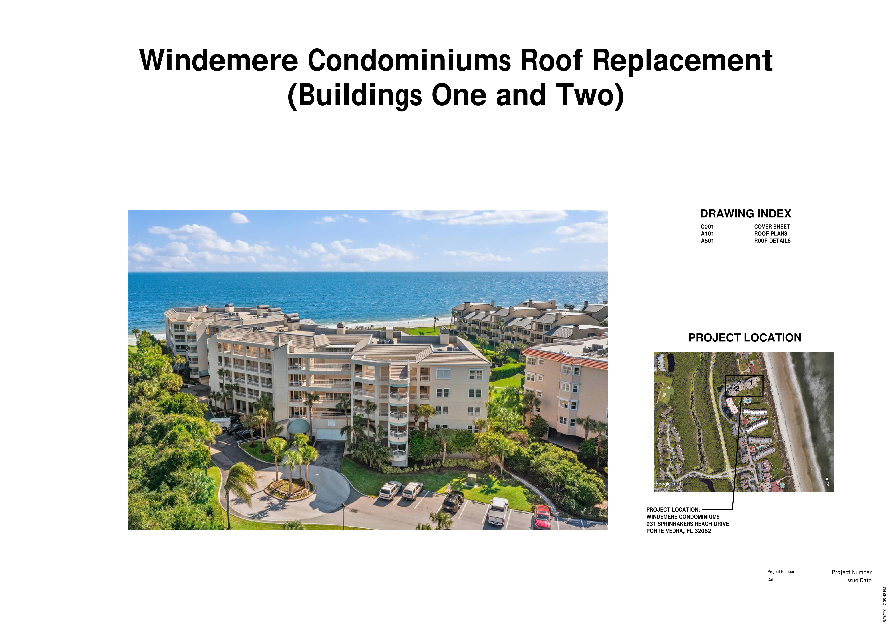
Sheet A101: Roof Plans
Isometric roof plans for Buildings One and Two showing the central low-slope areas being replaced (BUR to multi-ply modified bitumen), surrounding existing metal roof flanks, existing thru-wall scuppers and parapet drains, existing internal roof drains (RD), and existing rooftop equipment (D). Drawn at 3/32 inch = 1 foot.
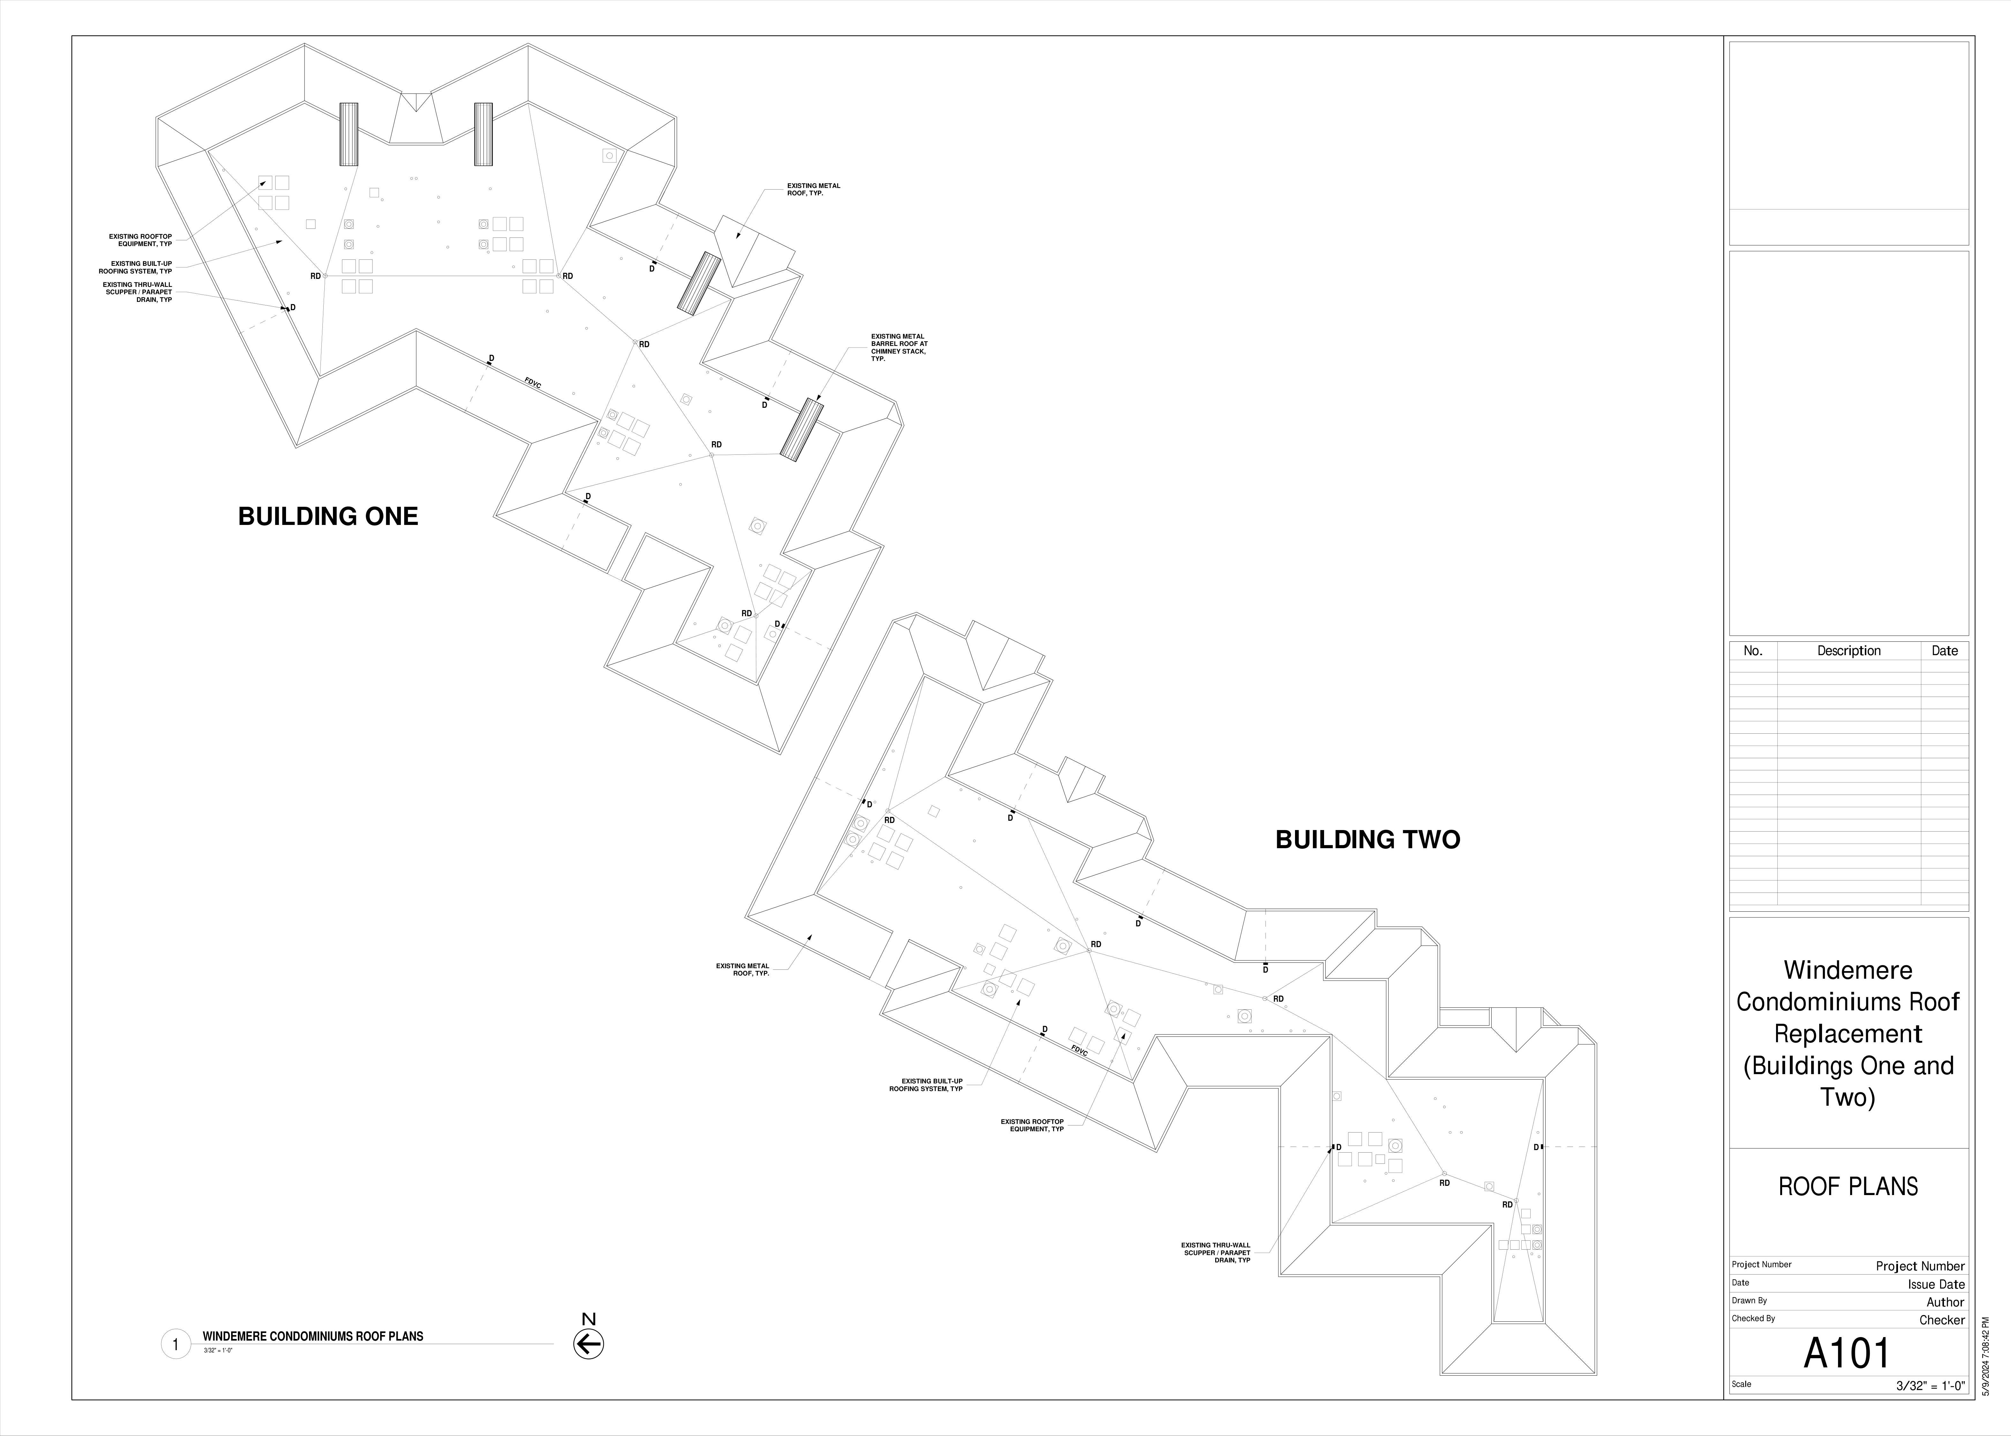
Sheet A501: Roof Details
Twelve standard roof details for the 2025 mod-bit installation: metal wall flashing, equipment roof curb, concrete wall flashing, conduit/piping thru roof deck, soft vent flashing, metal coping cap, equipment stand on wood blocking, load-bearing support, conduit/pipe support, roof drain with cast-iron clamping ring and strainer dome, two-ply target stripping at penetrations. These details define the as-designed conditions documented in the May 14, 2026 photographs.
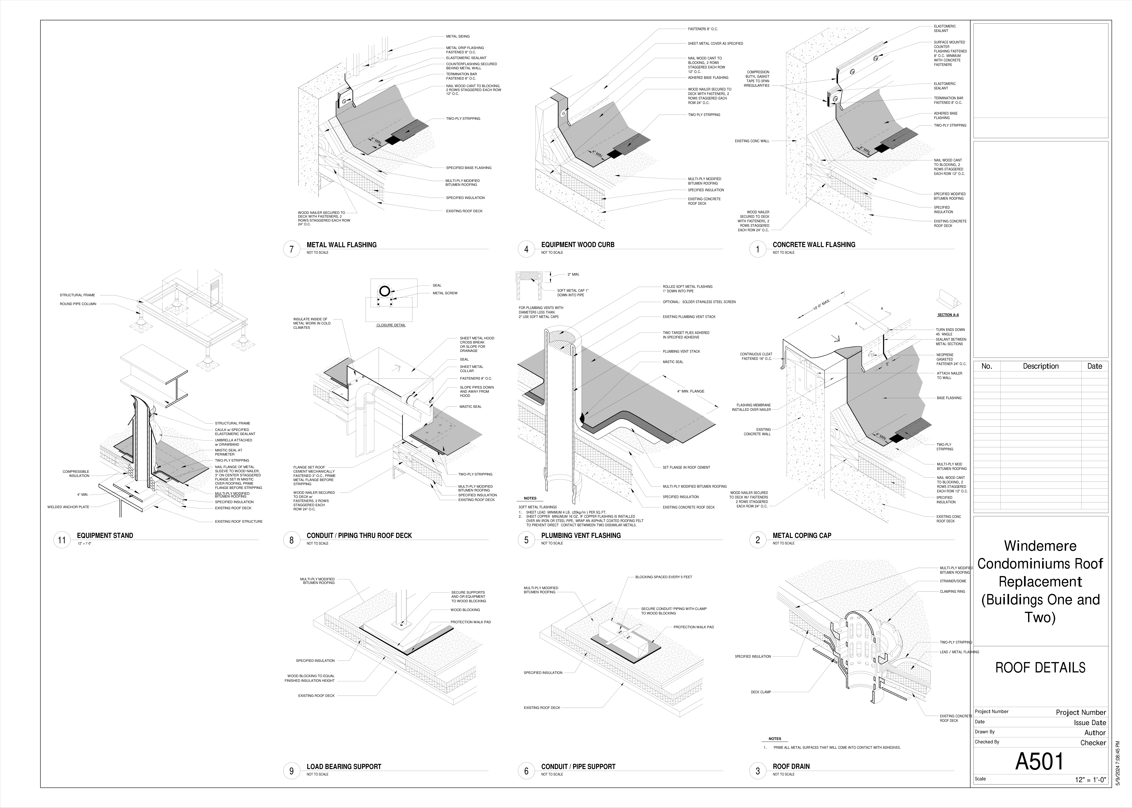
Sheet A701: Chimney Details
New aluminum chimney cap detail: side elevation, end elevation, cap plan, and section. The cap is a four-sided open-top louvered aluminum enclosure that sits above the existing chimney flues. The internal flue caps and spark arrestors above the flues are unit-owner-controlled and were not part of the 2025 common-element scope.
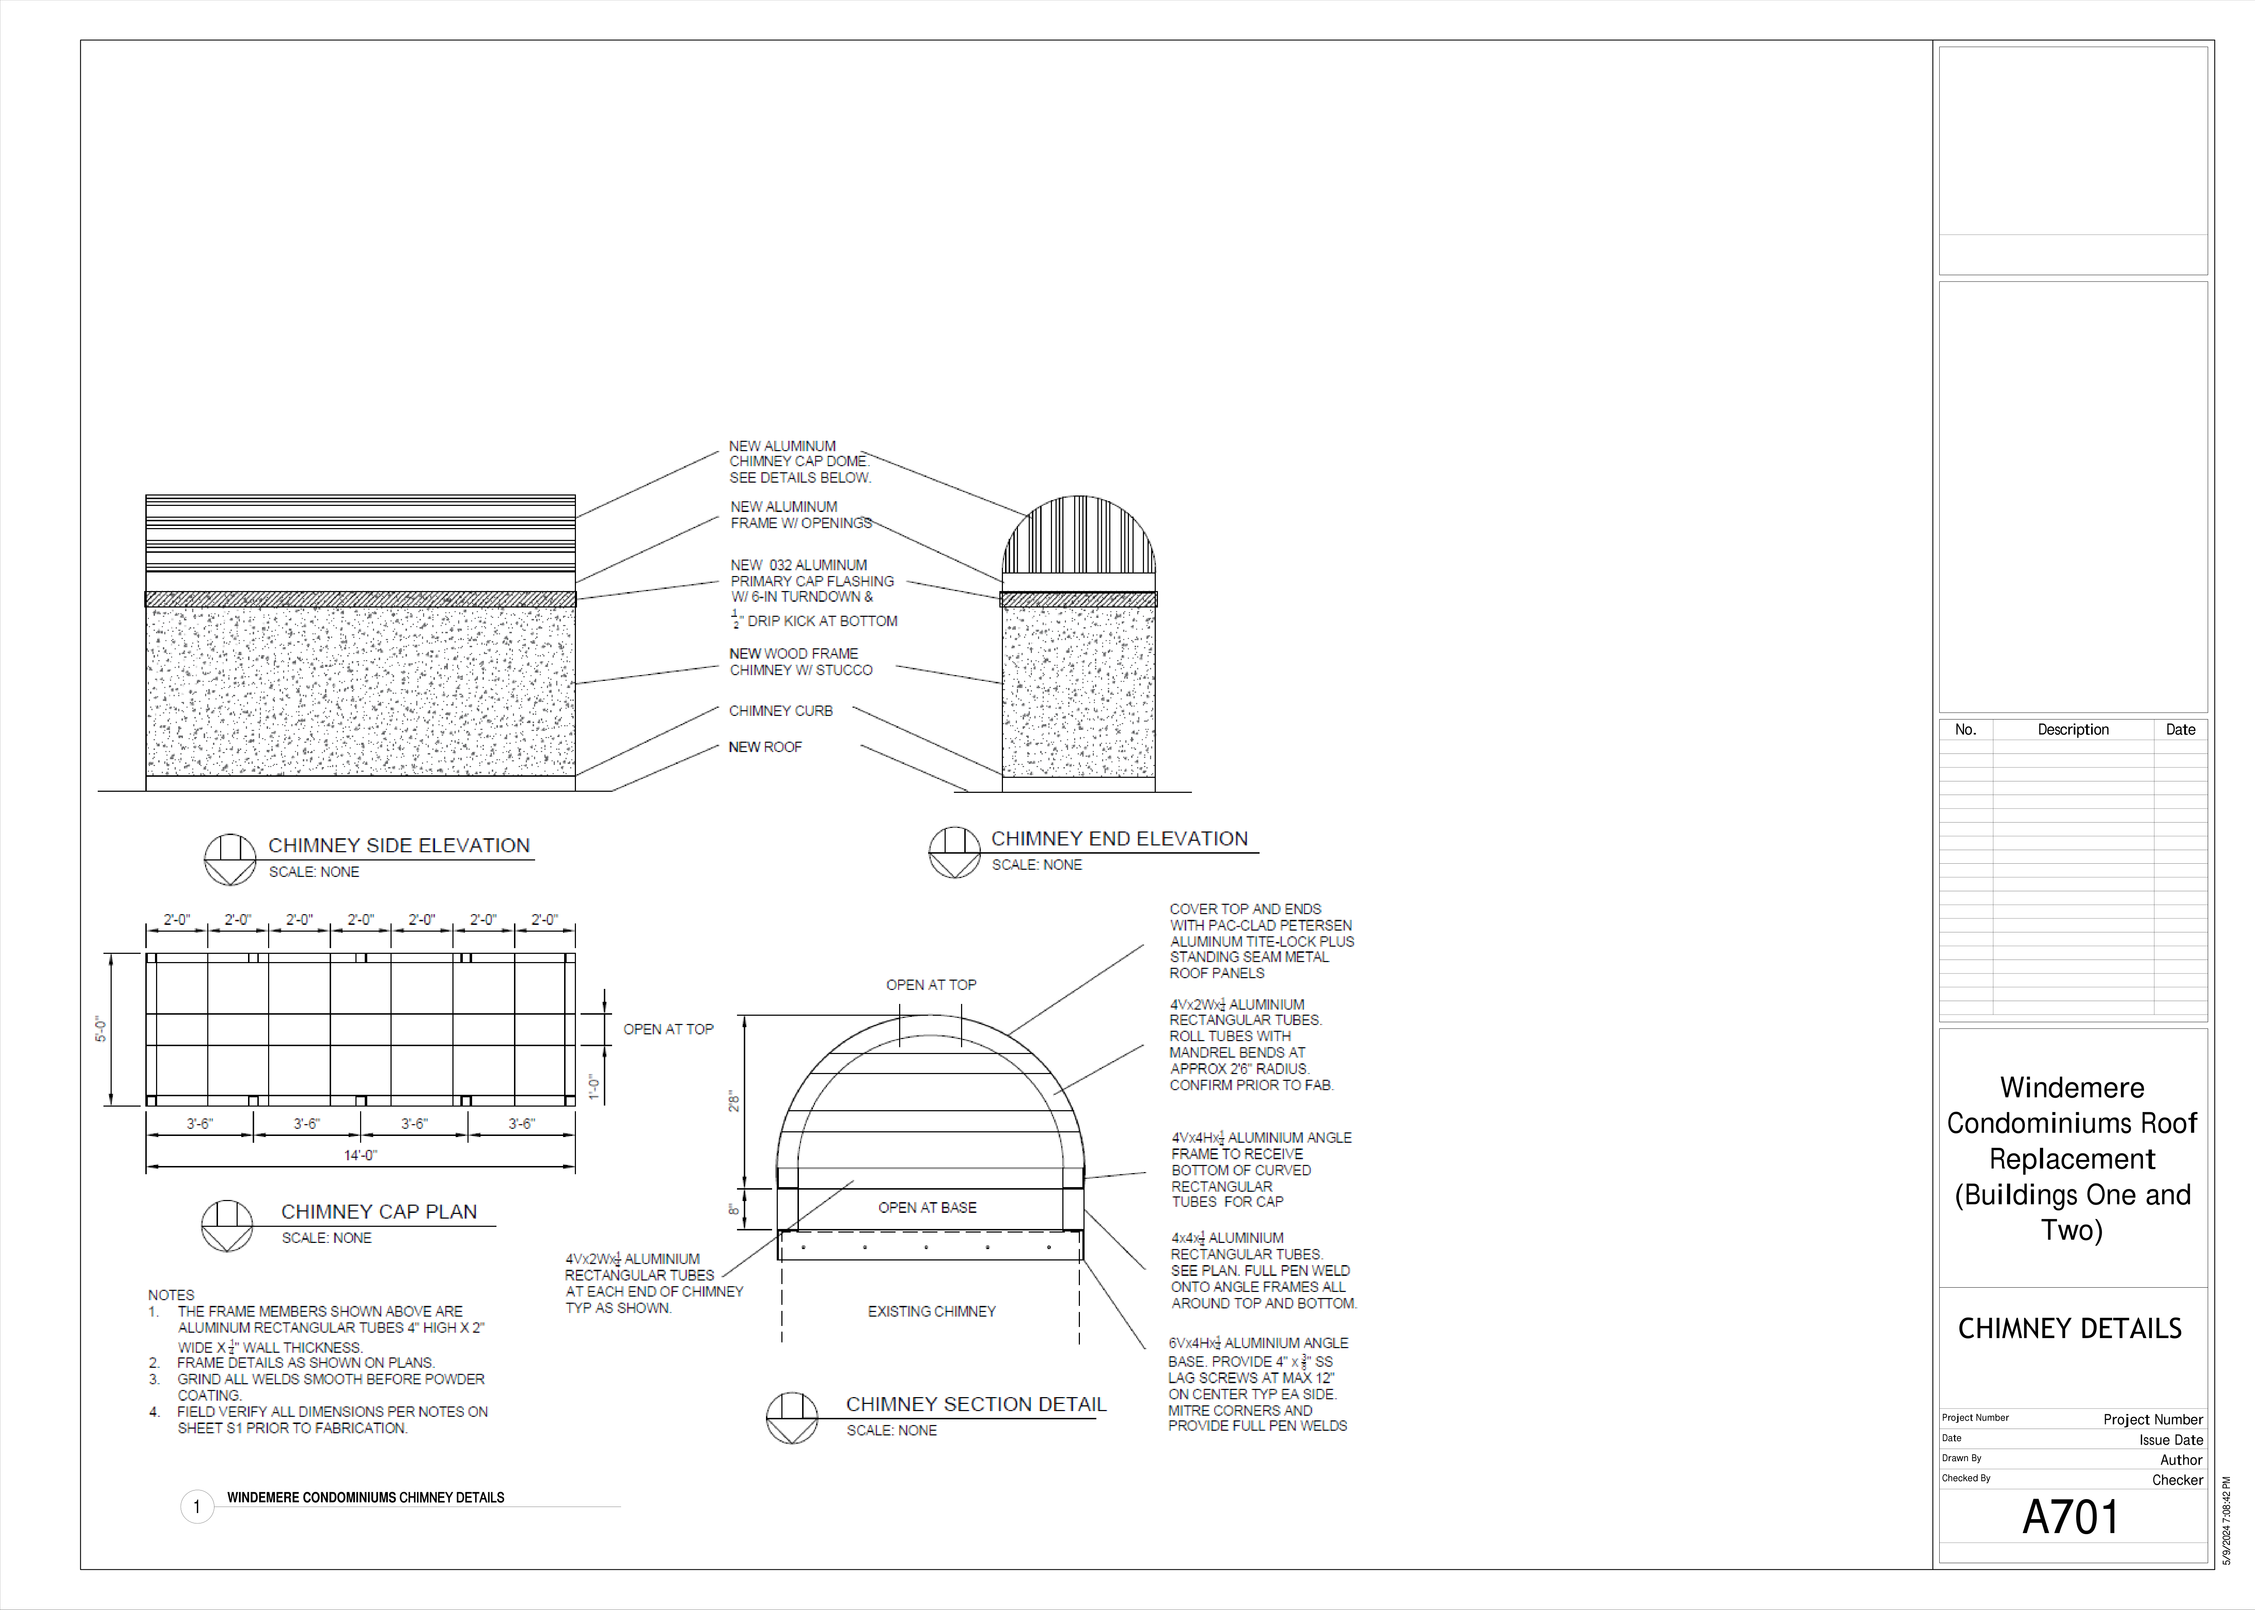

Inspector Signature and Seal
Respectfully submitted,
Kristophor C. Linster, P.E., RRC, CBECxP, LEED AP BD+C, CDT, RRO, CEI
Principal Engineer
Charles Taylor
kcl@cts-engco.com
[PE Seal Placeholder]

